Muhammad Zhillan Faza Raihan

Screenshots

Screenshots from Android Studio

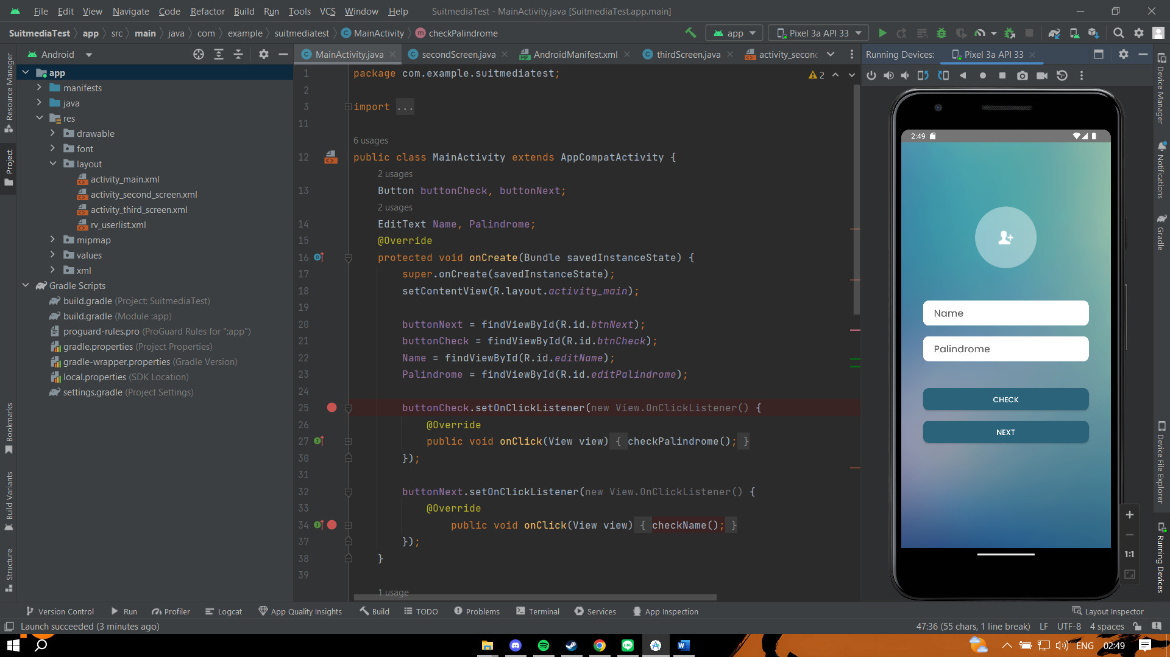

Testing APK on another device using BrowserStack

